Assignment 5

Objective
This assignment demonstrates how to implement Cross-Origin Resource Sharing (CORS) and secure a Web API using JWT (JSON Web Token) authentication in ASP.NET Core.
Key topics covered include:
- What is CORS and how to enable it
- JWT token generation and validation
- Role-based authorization using [Authorize] and claims
- Using Swagger and Postman to test protected API endpoints

Implementation Steps

Step 1: Enableb CORS
In Program.cs, add the following CORS policy:
builder.Services.AddCors(options =>
{
options.AddPolicy("AllowLocalhost3000",
builder => builder
.WithOrigins("http://localhost:3000")
.AllowAnyHeader()
.AllowAnyMethod());
});
...
app.UseCors("AllowLocalhost3000");

Step 2: Configured JWT Authentication
In Program.cs, configure JWT authentication:
string securityKey = "this_is_a_super_secure_256bit_key123!";
var symmetricSecurityKey = new SymmetricSecurityKey(Encoding.UTF8.GetBytes(securityKey));
builder.Services.AddAuthentication(x =>
{
x.DefaultAuthenticateScheme = JwtBearerDefaults.AuthenticationScheme;
x.DefaultChallengeScheme = JwtBearerDefaults.AuthenticationScheme;
x.DefaultSignInScheme = JwtBearerDefaults.AuthenticationScheme;
})
.AddJwtBearer(JwtBearerDefaults.AuthenticationScheme, x =>
{
x.TokenValidationParameters = new TokenValidationParameters
{
ValidateIssuer = true,
ValidateAudience = true,
ValidateLifetime = true,
ValidateIssuerSigningKey = true,
ValidIssuer = "mySystem",
ValidAudience = "myUsers",
IssuerSigningKey = symmetricSecurityKey
};
});
...
app.UseAuthentication();

Step 3: Created AuthController
Created a controller that generates a JWT token:
[ApiController]
[Route("api/[controller]")]
[AllowAnonymous]
public class AuthController : ControllerBase
{
[HttpGet("token")]
public IActionResult GetToken()
{
var token = GenerateJSONWebToken(1, "Admin");
return Ok(new { token });
}
private string GenerateJSONWebToken(int userId, string userRole)
{
var securityKey = new SymmetricSecurityKey(Encoding.UTF8.GetBytes("this_is_a_super_secure_256bit_key123!"));
var credentials = new SigningCredentials(securityKey, SecurityAlgorithms.HmacSha256);
var claims = new List<Claim>
{
new Claim(ClaimTypes.Role, userRole),
new Claim("UserId", userId.ToString())
};
var token = new JwtSecurityToken(
issuer: "mySystem",
audience: "myUsers",
claims: claims,
expires: DateTime.Now.AddMinutes(10),
signingCredentials: credentials);
return new JwtSecurityTokenHandler().WriteToken(token);
}
}

Step 4: Securing EmployeeController
Modified EmployeeController.cs to require authorization:
[ApiController]
[Route("api/[controller]")]
[Authorize(Roles = "Admin,POC")]
public class EmployeeController : ControllerBase
{
// existing code remains the same...
}

Step 5: Enable Authorize Button in Swagger
Add the following configuration to Swagger in Program.cs:
options.AddSecurityDefinition("Bearer", new OpenApiSecurityScheme
{
Name = "Authorization",
Type = SecuritySchemeType.ApiKey,
Scheme = "Bearer",
BearerFormat = "JWT",
In = ParameterLocation.Header,
Description = "Enter 'Bearer' followed by your JWT token."
});
options.AddSecurityRequirement(new OpenApiSecurityRequirement
{
{
new OpenApiSecurityScheme
{
Reference = new OpenApiReference
{
Type = ReferenceType.SecurityScheme,
Id = "Bearer"
}
},
Array.Empty<string>()
}
});

Step 6: Testing
- Used GET /api/Auth/token to generate a JWT.
- Used the Authorize button in Swagger or Authorization header in Postman.
- Access protected endpoints:
- Valid token → 200 OK
- Expired token → 401 Unauthorized
- Missing or invalid token → 401 Unauthorized
- Role mismatch → 401 Unauthorized

Screenshots
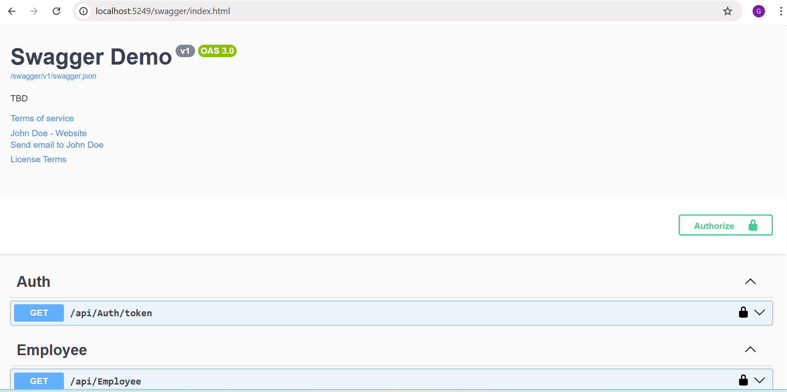
Swagger UI showing /api/Auth/token request and response:

Swagger Authorize popup with pasted token:
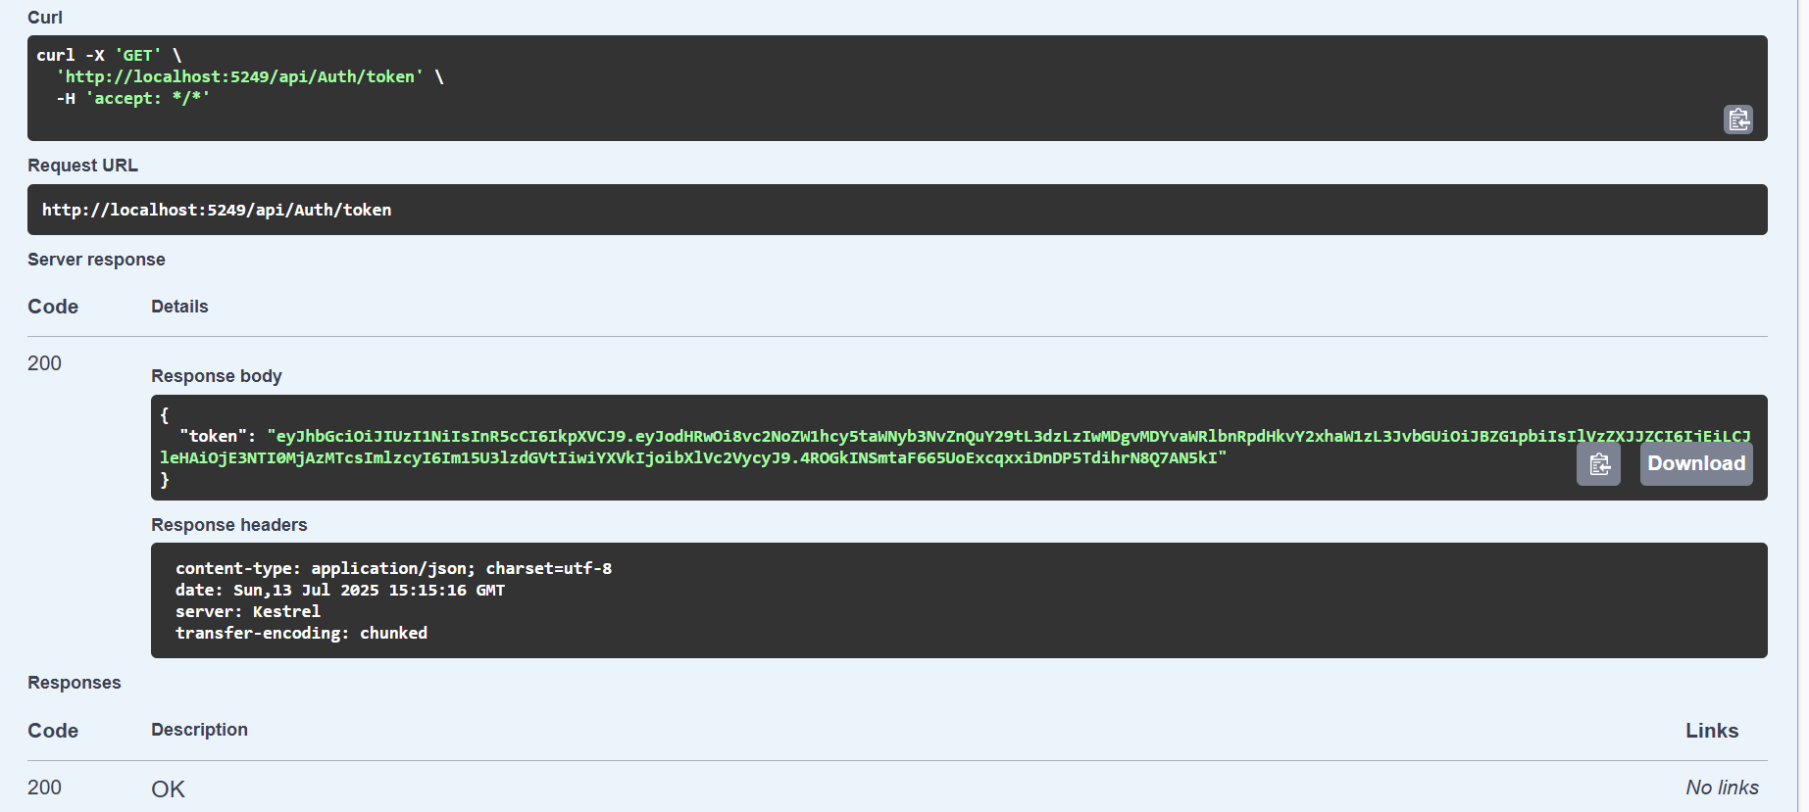

GET /api/Employee result with valid token (200 OK):
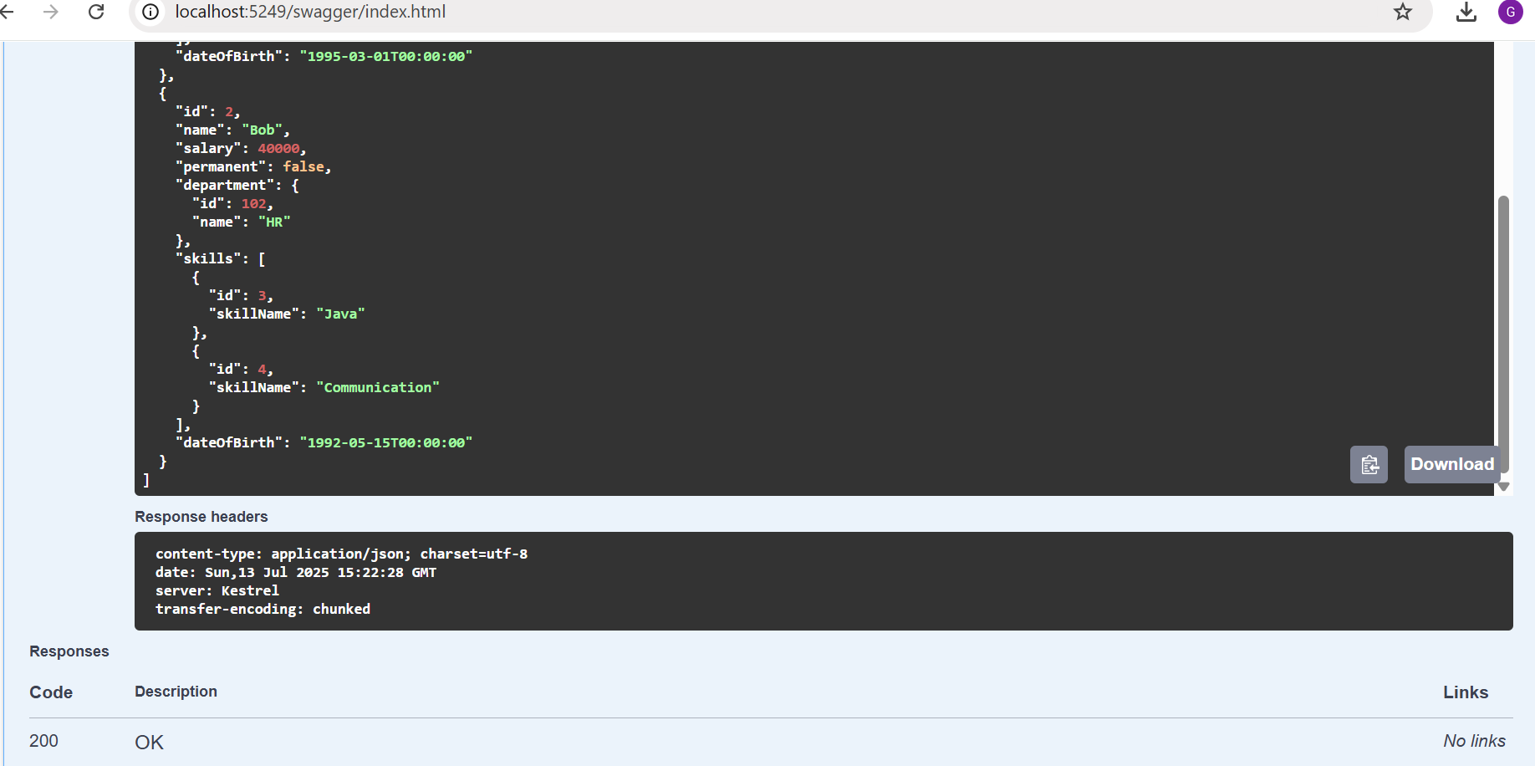

Postman test for authorized :
